

**Tribhuvan University**

**Faculties of Humanities and Social Sciences**

**HOSTEL MANAGEMENT SYSTEM**

**A PROJECT PROPOSAL**

**Submitted to**

**Department of Computer Application**

**Ratna Rajya Laxmi Campus**

***In partial fulfillment of the requirements for Bachelors in Computer Applications***

**Submitted by**

**Sagar Adhikari (6-2-40-50-2020)**

Under the Supervision of

**Bhupendra Ram Luhar**

Table of Contents

List Of Figures ii

1. Introduction 1

2. Problem Statement 1

3. Objectives 2

4. Methodology 3

a. Requirement Identification 3

i. Study of an Existing System 3

ii. Literature Review 4

iii. Requirement Analysis 5

b. Feasibility Study 6

i. Technical Study 6

ii. Operational Study 6

iii. Economic Study 6

c. High Level Design of System 7

i. Methodology 7

ii. Flowchart 8

iii. Description of Algorithm 9

5. Gantt Chart 10

6. Expected Outcomes 11

References 12

# List Of Figures

**Figure 1: Use Case Diagram of Hostel Management System** 5

**Figure 2: Waterfall Model** 7

**Figure 3: Flowchart of Hostel Management System** 8

# Introduction

The advancement of technology has evolved almost all sectors, including the hostel. The old technique of performing tasks of hostel manually, has evolved to the online system which has led to development of Hostel Management System (HMS). Hostel Management System is developed with the objective of automating tasks of hostel such as registration form, assigning rooms, updating students details and so on. This particular project also solves the problem with the data in hostel by reducing redundant data of students, manually updating students’ data in registers. Identification of the drawbacks of the existing system leads to the designing of computerized system that will be compatible to the existing system with the system which is more user friendly. By automating routine tasks, the HMS significantly reduces the administrative burden on hostel staff, allowing them to focus on providing a better living experience for residents.

The primary objectives of the Hostel Management System are to automate routine administrative tasks, thereby reducing manual workload and minimizing errors. This system aims to efficiently manage room allocations based on predefined criteria such as room capacity, availability, and student preferences, ensuring optimal utilization of hostel resources.

# Problem Statement

Various Hostel Management Systems are available, but some flaws make them inefficient. Along with that, the traditional method of managing hostel leads to inefficiencies, communication gap. Traditional methods of handling room allocations, fee collections, attendance tracking, and complaint management are time-consuming and prone to human errors. This manual approach often results in misplaced records, delayed responses to student issues, and lack of transparency in financial transactions. These problems highlight the need for an improved hostel management system to facilitate easier administration, enhance the student experience, and ensure more efficient and effective hostel operations.

# Objectives

The Hostel Management System is developed with the aim of completing following objectives:

* To provide user-friendly interface for students to book hostel accommodations.
* To allow admin to manage the hostel system.

# Methodology

## Requirement Identification

### i. Study of an Existing System

To explore more about hostel management systems, a broad study of systems such as hostelworld, hostelz were conducted. Every of these platforms have their own features, characteristics along with some drawbacks as well.

Hostelz allows to find hostel around the world in single click. Along with that, it also allows the comparing of the price of the hostels. It offers an simple and fascinating User Interface (UI) which allows the user for the better experience when interacting with the website. [1]

Agoda makes the task of the user easy by helping them find the hostel very comfortably. It offers a range of accommodation options, including hostels, with user reviews and competitive pricing. Along with that, it also allows the users to list their own place for other users. It eases the user task as they can book hostel based on the reviews. [2]

Hostelworld is another platform for booking hostel in an easy manner. It allows easy booking and flexible cancellation as well. It provides lower and competitive price among the websites, so that user can book the hostel at minimum cost. It provides easy and interactive UI for easy interaction for the user. [3]

### ii. Literature Review

The literature review for this project involved a depth exploration of existing research papers, articles and journals related to Hostel Management System (HMS). In addition to that broad research was conducted on existing platforms such as Hostelz, HostelWorld and so on. These platforms provide a significance knowledge for the development of the hostel management system. As is well-known, the education institutions are rapidly increasing for the past few years. Therefore, it leads to mushrooming of hostels for the accommodation of the students study in these institutions. And hence there is the appearance of Hostel Management System which helps with dealing the problem of managing hostel and avoid the problem when do it manually.

By studying findings from the literature review and analysis of existing systems, I gained

valuable insights that helped me in the design and development of Learning Management

System. These insights include understanding the importance of flexibility, user engagement, content quality, and the need for both structured and self-paced learning options.

### iii. Requirement Analysis

**Functional Requirements**

**Figure 1: Use Case Diagram of Hostel Management System**

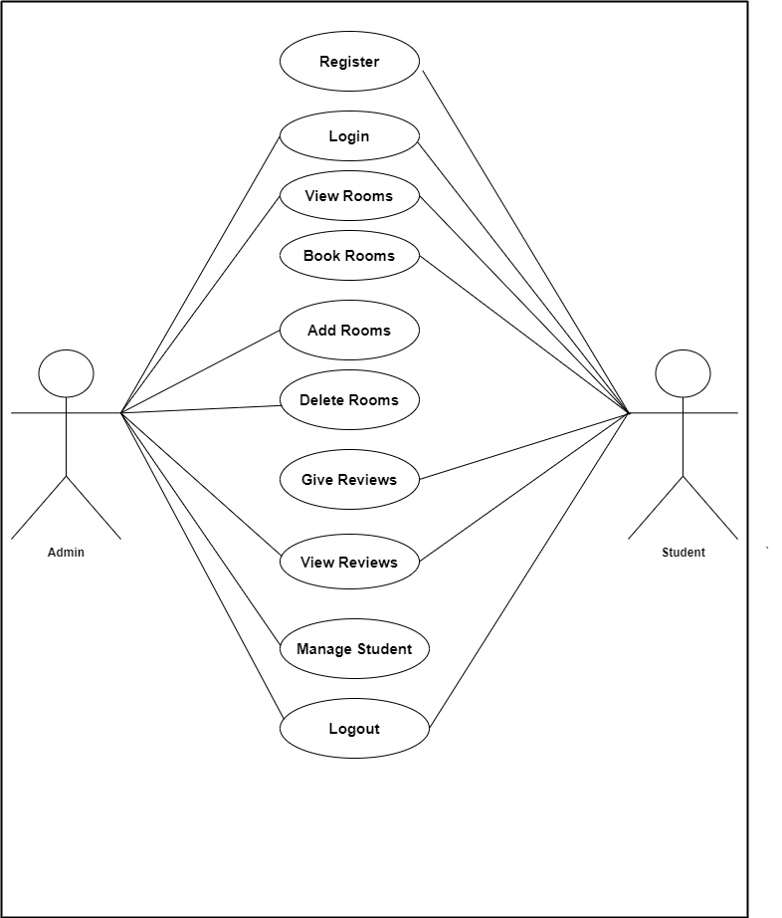

Students are allowed to register, login and logout from their account. Along with that they can view available rooms, book them and give reviews about the rooms and can view the reviews as well.

Admin can login and logout from the account. Admin can view rooms, add rooms and delete the rooms. Admin can manage the registered students and can view the reviews provided by the student as well.

**Non-Functional Requirements**

1. Availability: This is a web-based application, so it is available to anyone who can access it.
2. Security: Only the Admin can be able to make changes in the system thus, making it more secure.
3. Performance: This system is designed to perform in a way where the admin can be able to manage Users and all other functions of the system and where the Users will be able to login and view their information.
4. Reliability: This system is very reliable to manage and store the Users’ and admin information**.**

## Feasibility Study

### i. Technical Study

The system designed for this project is technically feasible because it does not need any extra or high functioning devices and the maintenance of the system would be easier too.

### ii. Operational Study

The system designed for this project is operationally feasible because it is very user friendly for the Users to use and the admin can operate it after they are provided with the basic training.

### iii. Economic Study

The system designed for this project is simple and cost-efficient and no further big changes would be required so it is economically feasible.

## c. High Level Design of System

### i. Methodology

For the development of Hostel Management System (HMS), we'll be using the Waterfall Model as the requirements are pre-known. In this methodology we will move to next step only after completing the current step.

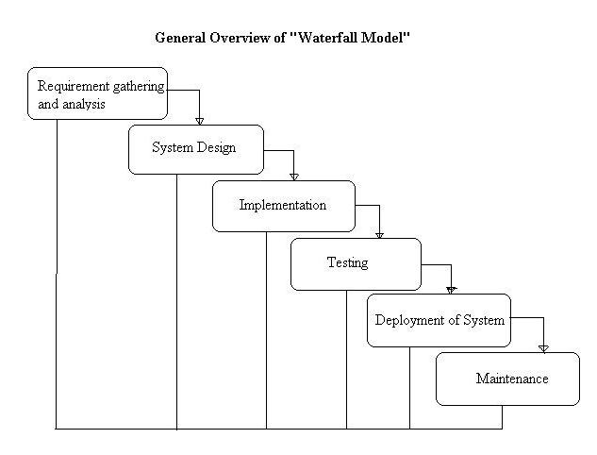

**Figure 2: Waterfall Model**

### ii. Flowchart

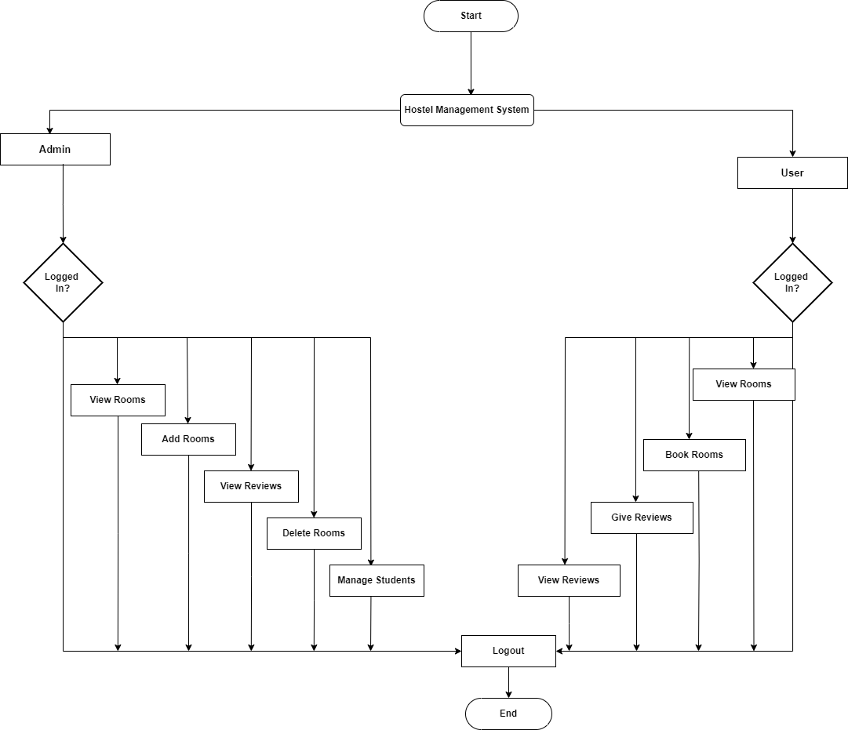

**Figure 3: Flowchart of Hostel Management System**

### iii. Description of Algorithm

This system uses queuing algorithm (Erlang B) to manage room occupancy and reservation probabilities. In this context, the formula helps calculate the blocking probability, which is the likelihood that a room reservation request will be denied because all rooms are occupied. By defining the offered traffic (E) as the average number of room reservation requests per day and the number of servers (N) as the total number of available rooms, the Erlang B formula can predict the probability of blocking. The formula is given by:

B(E,N)= $\frac{\frac{E^{N}}{N!}}{\sum_{k=0}^{N}{\frac{E^{K}}{K!}}}$

Where,

* B(E,N) is the blocking probability
* E is the offered traffic in Erlangs (e.g., average number of room reservation requests per day).
* N is the number of servers or lines (e.g., total number of rooms available).

# 5. Gantt Chart

|  |  |  |  |  |  |  |  |  |  |  |  |  |  |  |  |  |  |  |  |  |  |  |  |  |  |  |
| --- | --- | --- | --- | --- | --- | --- | --- | --- | --- | --- | --- | --- | --- | --- | --- | --- | --- | --- | --- | --- | --- | --- | --- | --- | --- | --- |
| **Phases of project**  **development** | **Year 2081** | | | | | | | | | | | | | | | | | | | | | | | | | |
| **Month** | | | | | | | | | | | | | | | | | | | | | | | | | |
| **Ashar** | | | | | | **Shrawan** | | | | | | | **Bhadra** | | | | | | **Ashwin** | | | | | | |
| **W 1** | **W 2** | **W 3** | **W 4** | | **W 1** | | **W 2** | | **W 3** | | **W 4** | | **W 1** | **W 2** | **W 3** | | **W 4** | | **W 1** | | **W 2** | | **W 3** | | **W 4** |
| **Planning** |  | |  | |  | |  | |  | |  | |  |  |  |  |  | |  | |  | |  | |  | |
|  | |
|  | |
| **Analysis** |  | |  | |  | |  | |  | |  | |  |  |  |  |  | |  | |  | |  | |  | |
|  | |  | |  | |
|  | |  | |  | |
| **Design** |  | |  | |  | |  | |  | |  | |  |  |  |  |  | |  | |  | |  | |  | |
|  | |  | |  |  |
|  | |  | |  |  |
| **Coding** |  | |  | |  | |  | |  | |  | |  |  |  |  |  | |  | |  | |  | |  | |
|  |  |  | |
|  |  |  | |
| **Testing** |  | |  | |  | |  | |  | |  | |  |  |  |  |  | |  | |  | |  | |  | |
|  |  |  | |  | |  | |  | |
|  |  |  | |  | |  | |  | |
| **Deployment** |  | |  | |  | |  | |  | |  | |  |  |  |  |  | |  | |  | |  | |  | |
|  | |
|  | |
| **Documentation** |  | |  | |  | |  | |  | |  | |  |  |  |  |  | |  | |  | |  | |  | |
|  | |  | |  | |  | |  | |  | |  |  |  |  |  | |  | |  | |  | |  | |
|  | |  | |  | |  | |  | |  | |  |  |  |  |  | |  | |  | |  | |  | |

# 6. Expected Outcomes

Implementing the Hostel Management System is expected to bring several positive outcomes. It will make tasks like assigning rooms, managing fees, tracking attendance, and handling complaints much easier and more efficient. By automating these tasks, it will reduce the workload for staff and cut down on mistakes in financial records and resident details. Better communication between administrators and residents will also be a benefit, ensuring that important information reaches everyone quickly and that student concerns are addressed promptly. Overall, these improvements should lead to a smoother experience for residents, clearer administrative decisions, and higher satisfaction levels in the hostel.

# References

|  |  |
| --- | --- |
| [1] | "Hostelz," [Online]. Available: https://www.hostelz.com/. [Accessed 06 July 2024]. |
| [2] | "Agoda," [Online]. Available: https://www.agoda.com/. [Accessed 6 July 2024]. |
| [3] | "HostelWorld," [Online]. Available: https://www.hostelworld.com/. [Accessed 06 July 2024]. |